**Determining the Rate Law: A Kinetics Study of Iodination of Acetone**

He Wenxin何雯欣

March 27, 2019

Student ID 518370910117

Section 3

Group 3

Members Qiu Jiahao 裘嘉豪

Feng Hanyang 冯瀚扬

Xu Jiaying 许佳滢

Telephone 15921193245

Email Address wenxin_he@sjtu.edu.cn

University of Michigan-Shanghai Jiao Tong University Joint Institute(UM-SJTU JI)

# Ⅰ OBJECTIVES

* Understand kinetics quantitatively
* Express the rate and order of an reaction according to reactants and the rate constant
* Use the fixed rate law to predict the time of reaction

# Ⅱ INTRODUCTION

Commonly, an increase in concentration of reactants will result in an increase in the rate. However, the relationship between the multiple of increase in concentration and the rate differs from reaction to reaction. Scientists study this relationship and express it in a useful form.

# Ⅲ BACKGROUND

1. **The Rate Law**

For a chemical equation aA+bB→cC+dD, the rate law( or the rate equation) is expressed in the form rate= $k{[A]}^{m}{[B]}^{n}$. k is called rate constant, which depends on temperature and is unique for each reaction. m and n are determined experimentally. Firstly, to determine the order, we should do many control experiments and determine m and n respectively by comparing the data of different experiments. Secondly, we plug in the values of the initial concentration of each reactant, their orders and the initial rate to calculate k. The unit of k depends on the order of the reaction, and just make sure the unit of the right hand side of the equation equals to M/s. The overall order of reaction=m+n.

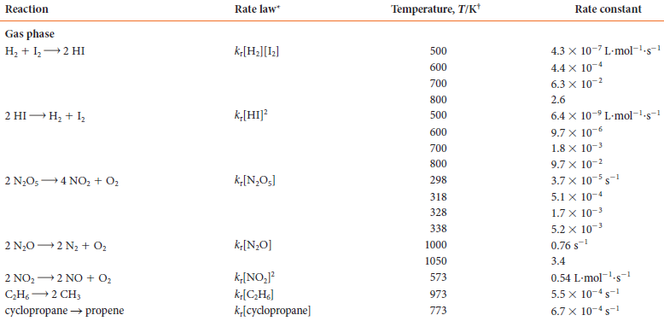

**Table 1** Rate law and rate constant

**B. The Iodination of Acetone**

# In this experiment, we will study the kinetics of the reaction

# C $H_{3}COCH_{3}\left(aq\right)+I_{2}$ (aq)→C $H_{3}COCH_{2}I\left(aq\right)+H^{+}\left(aq\right)+I^{-}(aq)$

# The amount of acetone will be kept very large to make the rate of reaction remain constant through the experiment so that the initial rate equals the average rate. The average rate can be expressed in the following way:

$$Rate=\frac{-∆[I_{2}]}{∆t}=\frac{-({\left[I_{2}\right]}_{final}-{[I_{2}]}_{initial})}{∆t}$$

# In this reaction, the color changes from yellow to colorless. Therefore, it’s easy to spot the end of the reaction where [I2]final =0M.

# Ⅳ OVERVIEW

# We should guarantee the precision of data because this is a quantitative experiment. We should follow the rules, read through the procedure and complete the data table before the lab.

# Ⅴ EXPERIMENTAL PROCEDURES

|  |  |
| --- | --- |
| Chemicals used | Materials used |
| 4 M Acetone (100 mL)  1M HCl (100 mL)  0.00118 M Iodine (100 mL)  De-ionized water (DI H2O) | 50 mL graduated cylinders (4)  100 mL Beakers (4)  125 mL Erlenmeyer flasks (5)  Plastic pipet (4)  Stop – watch  Stir – plate and stir bar (optional) |

1. Thoroughly clean the glassware on the workstation, which includes four 100-mL beakers, four 50-mL graduated cylinders, and five 125-mL Erlenmeyer flasks. Rinse all the glassware with deionized water and dry them. All the graduated cylinders are labeled with “Acetone”, “HCl”, “I2”, “DI H2O”. Rinse each graduated cylinder with 2 – 3 mLs of the corresponding solution.

2. Prepare a blank with only DI water used to compare color change. When observing color changes, put a white paper behind the flasks to see the color more clearly.

3. Use the corresponding graduated cylinders to measure certain volumes of solution and prepare each solution according to the designed table but do not add iodine into the solution. Add 2 drops of starch solution into the flask to make the color change more distince.

4. Get your stop watch ready, measure certain volume of 0.00118 M iodine according to the table into the clean “I2” graduated cylinder. Place the Erlenmeyer flask with acetone in it onto the stir – plate and drop carefully a stir bar into the solution. Set a stir plate to a medium setting. Get the stop watch started as soon as you quickly pour all the iodine solution into the flask. The solution will be yellow initially when iodine is added. Then the color will change to blue because of the existence of starch. With the reaction proceeding, the blue color will finally fade away as iodine is consumed completely, meaning the reaction has reached the end point. Immediately stop timing as soon as the blue color fades. Record the time on the datasheet. Do not use the heating mode on the stir plate (do not heat sample).

5. When all 4 trials are done, repeat the following steps again to make your result more accurate.

6. Make sure the total volume of reacting solution is 50mL and the volume of HCl must be 10mL.

7. Use the data recorded and find suitable ways to calculate the order with respect to I2 and acetone. Also calculate the rate constant k. Finally, write down the equation expressing the rate of this reaction.

**Ⅵ CALCULATION/ANALYSIS/DATA PROCESSING**

**A. Calculation**

|  |  |  |  |  |  |  |
| --- | --- | --- | --- | --- | --- | --- |
| Number | 1M HCl(mL) | 4M Acetone(mL) | DI Water(mL) | 0.00118M Iodine(mL) | Initial Acetone Concentration(M) | Initial Iodine concentration(M) |
| 1 | 10.0 | 10.0 | 20.0 | 10.0 | 0.8 | 2.36 $×{10}^{-4}$ |
| 2 | 10.0 | 10.0 | 10.0 | 20.0 | 0.8 | 4.72 $×{10}^{-4}$ |
| 3 | 10.0 | 20.0 | 10.0 | 10.0 | 1.6 | 2.36 $×{10}^{-4}$ |
| 4 | 10.0 | 15.0 | 10.0 | 15.0 | 1.2 | 3.54 $×{10}^{-4}$ |

**Table 2** the designed table

Then we record the time of each reaction.

|  |  |  |  |
| --- | --- | --- | --- |
| Number | Trial 1 time(s) | Trial 2 time(s) | Average time(s) |
| 1 | 16 | 18 | 17 |
| 2 | 37 | 35 | 36 |
| 3 | 10 | 10 | 10 |
| 4 | 18 | 18 | 18 |

**Table 3** Time for each reaction

We calculate the initial rate for each reaction:

$$Rate=\frac{-∆[I_{2}]}{∆t}=\frac{-({\left[I_{2}\right]}_{final}-{[I_{2}]}_{initial})}{∆t}$$

Reaction 1: Rate= $\frac{-(0-2.36×{10}^{-4})}{17}M/s$ =1.39 $×{10}^{-5}$ M/s

Reaction 2: Rate= $\frac{-(0-4.72×{10}^{-4})}{36}M/s$ =1.31 $×{10}^{-5}$ M/s

Reaction 3: Rate= $\frac{-(0-2.36×{10}^{-4})}{10}M/s$ =2.36 $×{10}^{-5}$ M/s

Reaction 4: Rate= $\frac{-(0-3.54×{10}^{-4})}{18}M/s$ =1.97 $×{10}^{-5}$ M/s

To help with our calculation, we organize the data in table 4.

|  |  |  |  |
| --- | --- | --- | --- |
| Number | Initial Acetone Concentration(M) | Initial Iodine Concentration(M) | Initial Rate(M/s) |
| 1 | 0.8 | 2.36 $×{10}^{-4}$ | 1.39 $×{10}^{-5}$ |
| 2 | 0.8 | 4.72 $×{10}^{-4}$ | 1.31 $×{10}^{-5}$ |
| 3 | 1.6 | 2.36 $×{10}^{-4}$ | 2.36 $×{10}^{-5}$ |
| 4 | 1.2 | 3.54 $×{10}^{-4}$ | 1.97 $×{10}^{-5}$ |

**Table 4** Data for calculation

Then we calculate the value of m&n in the general form of the rate law.

Rate $=k{[Acetone]}^{m}{[Iodine]}^{n}$

* To calculate m, we compare #1&3:

1.39 $×{10}^{-5}=k{[0.8]}^{m}{[2.36×{10}^{-4}]}^{n}$

2.36 $×{10}^{-5}=k{[1.6]}^{m}{[2.36×{10}^{-4}]}^{n}$

m= $\log_{2}\frac{2.36}{1.39}$ =0.76

* To calculate n, we first compare #1&2:

1.39 $×{10}^{-5}=k{(0.8)}^{m}{(2.36×{10}^{-4})}^{n}$

1.31 $×{10}^{-5}=k{(0.8)}^{m}{(4.72×{10}^{-4})}^{n}$

n= $\log_{2}\frac{1.31}{1.39}$ = -0.09

This data is clearly wrong according to the theory. There must be some errors during this trial; therefore, we abandon this data and compare #1&4:

1.39 $×{10}^{-5}=k{(0.8)}^{m}{(2.36×{10}^{-4})}^{n}$

1.97 $×{10}^{-5}=k{(1.2)}^{m}{(3.54×{10}^{-4})}^{n}$

n= $\log_{\frac{3.54}{2.36}}\frac{1.97}{1.39}×{(\frac{0.8}{1.2})}^{m}$ = 0.10 (we use m=0.76)

* Now that we’ve got the value m=0.76 and n=0.10, we plug in data of the first reaction to calculate k:

1.39 $×{10}^{-5}= k{×0.8}^{0.76}{×(2.36×{10}^{-4})}^{0.10}$

k = $\frac{1.39×{10}^{-5}M/s}{{0.8M}^{0.76}{×(2.36×{10}^{-4}M)}^{0.10}}$ = 3.80 $×{10}^{-5}M^{0.14}∙s^{-1}$

Therefore, the rate law is:

Rate $=3.8×{10}^{-5}M^{0.14}{∙s^{-1}[Acetone]}^{0.76}{[Iodine]}^{0.10}$

**B.Analysis**

To test the rate law, we plug in the values of the four reactions and calculate the theoretical initial rate.

* For reaction 1, the theoretical rate should be 1.39 $×{10}^{-5}$ which is equal to the measured rate because the value k is deducted from this reaction.
* For reaction 2, the theoretical rate should be

$3.8×{10}^{-5}{×0.8}^{0.76}{×(4.72×{10}^{-4})}^{0.10}$ =1.50 $×{10}^{-5}$, which is much higher than the measured rate. The error analysis is shown in the discussion part.

* For reaction 3, the theoretical rate should be

$3.8×{10}^{-5}{×1.6}^{0.76}{×(2.36×{10}^{-4})}^{0.10}$ =2.36 $×{10}^{-5}$, which is equal to the measured rate with accuracy of two decimal points.

* For reaction 4, the theoretical rate should be

$3.8×{10}^{-5}{×1.2}^{0.76}{×(3.54×{10}^{-4})}^{0.10}$ =1.97 $×{10}^{-5}$, which is equal to the measured rate with accuracy of two decimal points.

**Ⅶ DISCUSSION**

Consider the second reaction, from the raw data we can see that when concentration of iodine increased, the initial speed decreased, which is the opposite of what the theory suggests. The actual rate should be higher than measured. The error of reaction 2 might be:

* We started the watch as soon as the iodine left the graduated cylinder. The right way is to start the watch when the iodine solution touch the acetone solution in the flask. This error made the time counted longer and resulted in the lower measured rate.
* The stirring speed was too low which resulted in inhomogeneous reaction and had certain effects on the results of all four experiments.
* There existed errors when preparing the solution. The actual concentration might be lower than designed.

What’s more, we find it very inaccurate to determine the reaction time by observing the color change of the solution. Although we used a blank solution to compare the color, it was still difficult to determine the actual end point of the reaction because the color changed from a darker one to a lighter one.

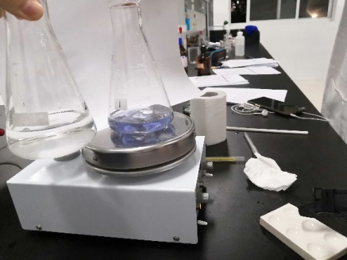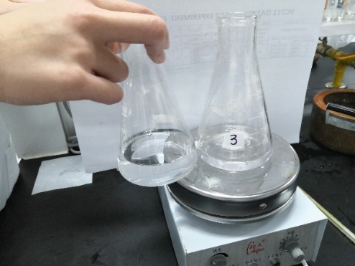

**Figure 1** Color change of this reaction

**Ⅷ CONCLUSIONS ＆ RECOMMENDATIONS**

This is a quantitative experiment so that we have to ensure the accuracy of the data. Although we have paid much attention to the preparing of the solutions and time counting, there still existed some errors which caused the 2nd data to be invalid.

Also, the stirring speed must be controlled at the same rate throughout the 8 trials.

This experiment enhances our understanding of chemical kinetics. We can determine the order of the reaction and the constant k by conducting experiments in person. However, this experiment is designed unreasonably in some way. It is hard to determine the starting time and end point just by observation. Some efforts should be made to accurately measure the reaction time.

**Ⅸ REFERENCES**

-1. Peter Atkins, *Chemical Principles The Quest for Insight Seventh Edition*, Macmillan education, 2016.

-2. VC211 Laboratory Manual, UM-SJTU JI &SJTU Chemistry Department, 2018-2019.